**Communication Audit Report on North 38 Apartment Complex**



**Group Members:**

Katharine Williams

Kolbe Jorgenson

Will Dyer

Drew Mayo

George Ahearn

**Table of Contents**

Table of Contents…………………………………………………………………..…….………..1

Organizational Description…………………………………………………………….….………2

Organizational Description Continued……………………………………………………………3

Organizational Description continued…………………………………………………………….4

Organizational Description Continued……………………………………………………………5

Central Question…………………………………………………………………………………..6

Data Collection……………………………………………………………………………………6

Culture Scan……………………………………………………………………………………….6

Culture Scan Continued…………………………………………………………………………...7

Surveys…………………………………………………………………….………………………8

Communication Systems map…………………………………………………………………….8

Interviews…………………………………………………………………………………………9

Interviews Continued…………………………………………………………………………….10

SWOC……………..….……………………………………………………………….…………11

SCOW Continued………………………………………………………………………………..12

Recommendations………………………………………………………………………………..13

### **Organizational Description:**

The North 38 apartment complex is located at 1190 Meridian Circle, 22802 in Harrisonburg, Virginia. Relative to Harrisonburg, the North 38 apartment complex can be found approximately two miles northeast of the James Madison University campus, and is a short, typically sub-ten minute drive to the campus. The complex provides a secluded feel, while also providing a location in which it is a short drive to whatever destination a tenant may be trying to reach. The complex was established in 2009, and now it consists of nineteen different buildings, each with three stories, which in total consists of 228 separate units.

Each tenant pays anywhere from $567 per month to $637 per month depending on a variety of factors. The cheapest option for tenants is the standard, four bedroom apartment which is $567 per tenant each month. The next cheapest option is the standard, three bedroom apartment which is $587 per tenant each month. Another option is the premium apartment with four bedrooms which is $617 per tenant each month. Finally, the most expensive option is the three bedroom premium apartment which costs $637 per tenant each month. These costs can vary approximately fifteen dollars depending on where the tenants purchase their rental insurance.

Additional to the rent installment each month is a $38 fee for all-inclusive amenities and utilities. If a tenant desires to have pets in their apartment, there are a few rules and guidelines they must follow. First, each apartment is allowed a maximum of two pets. Also, tenants with pets have to pay a one-time $300 payment, as well as $25 per month in addition to the tenants rent payment. Tenants in a premium apartment pay an additional $35 on top of the utility fee and monthly rent installment for multiple different upgrades.

Each standard apartment comes furnished, which includes items such as private bedrooms and bathrooms, a 55” smart TV, high speed internet, full size washer/dryer, dishwasher, garbage disposal, cable, fully furnished units, and private patios/balconies. The premium apartments include everything from the standard apartment with added bonuses including new stainless steel appliances, an upgraded designer furniture package, new kitchen countertops, a remote control LED fan in the common area, upgraded lights in common areas, new upgraded washer and dryer, and an accent wall. An accent wall is a specific wall in the room that is painted a different color to add a decorative flair.

North 38’s complex entrance is simply a sign that says “North 38” on it. However, the landscaping around the complex entrance is kept up with. The entrance consists of 1 main road with parking along the side, this makes every building equally located from different amenities.

Each apartment is also given a mailbox for envelopes and small packages located at the clubhouse. Bigger packages get delivered to the clubhouse, and the office emails that a tenant has a package. To pick-up a package, tenants show their I.D. and the employees will bring it out for the tenant.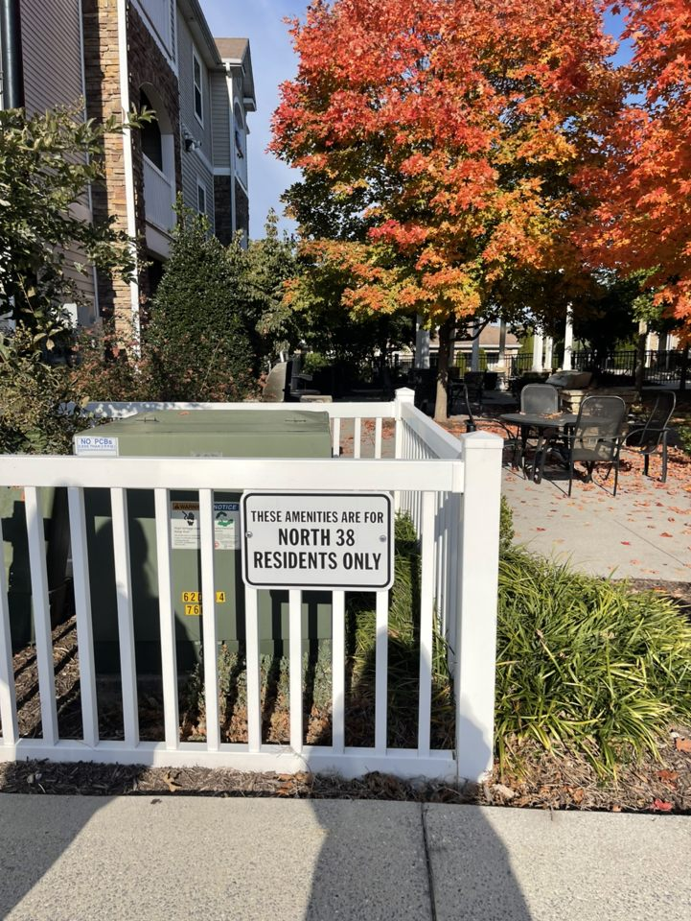

There are basic signs all around the complex to alert tenants to different amenities and warnings. Also, there are multiple signs throughout that complex stating “These Amenities Are For North 38 Residents Only.” There are also multiple “No Trespassing” signs throughout the complex and around different amenities.

North 38 includes a lot of amenities: gym, pool, study lounges, gazebo/ hammock area, sand volleyball, transportation to JMU, game room, car wash 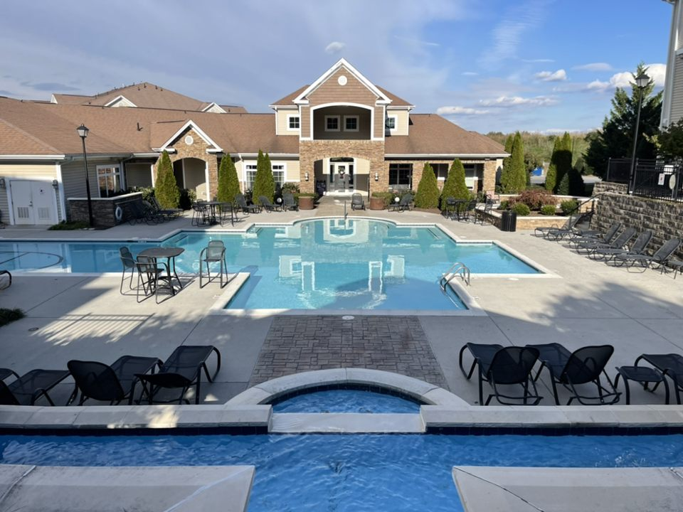station, dog parks, 24 hour coffee bar, mind and body studio, guest parking, tanning salon, free printing, 100+ security cameras, door-to-door trash pickup, and outdoor grills.

The office or “clubhouse” is a clean space dedicated to the comfort of the residents. There are multiple couches in the clubhouse, the lighting is soft, and the employees are always ready and willing to help with whatever they can. It is located in the center of the complex which conveniently places it in close proximity to all residential buildings. It is always decorated according to the season, currently being winter/Christmas themed. The office is always advertising North 38, and had a skeleton wearing a North 38 t-shirt during halloween. There are TVs that give different information about North 38 and advertise other things in the Harrisonburg area. 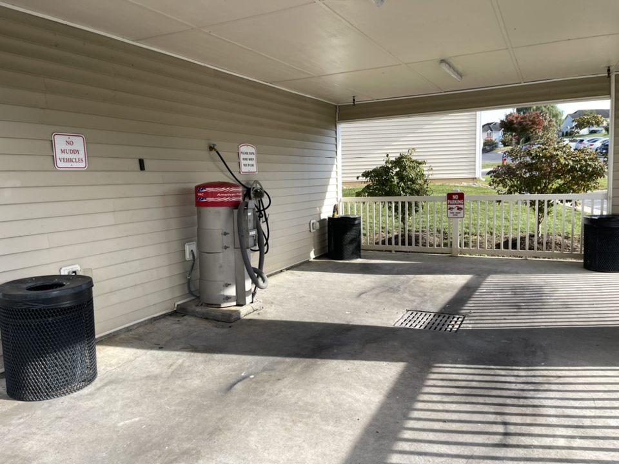

Connected to the clubhouse is a wide array of amenities offered by North 38. The gym, study lounges/game room, coffee bar, tanning salon, and mind and body studio are located in the Clubhouse. The gym is equipped with workout machines for all different kinds of workouts. The gym contains a smith machine (used for weight training), dumbbells, cables, ab machines, and even a variety of cardio machines. The study lounges and game room provide a quiet space for students that want to study, and a fun hangout space for students that do not want to commute all the way to campus.

The JMU campus bus and North 38’s bus both provide transportation to JMU’s campus every 30 minutes. The car wash station is equipped with a vacuum and pressure washer. North 38 also offers door-to-door trash pickup. Every night tenants can set out 2 bags of trash and they collect it around 8 pm.

The maintenance staff and management is on site to respond to requests and there is also a 24 hour maintenance line for emergencies. North 38 also takes advantage of the Resident Portal system, which is an app/ website where you can submit maintenance requests, reserve study rooms/ tanning beds, and even pay rent. The North 38 website has a very efficient design that is easy to follow for prospective residents, and current residents. The tagline of North 38 is “Your Adventure Awaits,” it is what you see as soon as you open the website. This is to make prospective residents curious, so they scroll down and see everything North 38 has to offer. 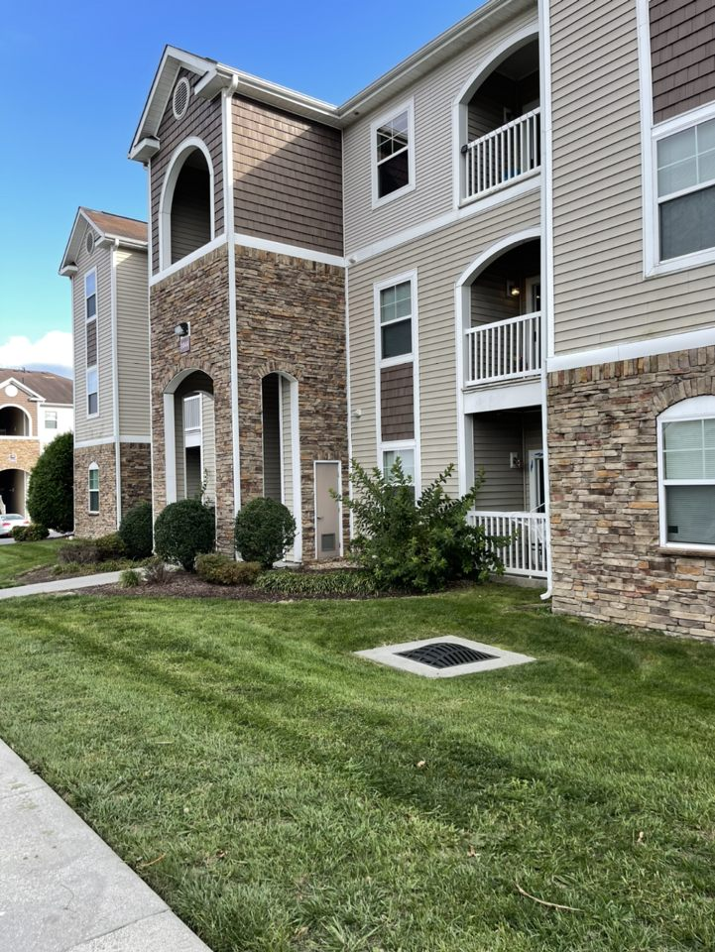

The landscaping at North 38 is constantly kept up with, the grass is always freshly mowed and the leaves are always blown off the sidewalks. Even the dumpster area is kept up with, considering it is a dumpster. North 38 has taken immense measures to make sure that the outside of the buildings and landscaping always looks its best.

The office workers mentioned that every employee at North 38 lives at the complex, and that many of them are students in the area. The employees living here allows them to experience the same things tenants do, which gives them the opportunity to make improvements accordingly.

### 

### **Central Question:**

In this communication audit of the North 38 apartment complex, we created one central focus that we aimed to learn: which channel of communication is effective at North 38 and which channels of communication are not helpful and could be improved? In North 38, there are a variety of different channels of communication that tenants can use to contact management or maintenance if they have any issues or questions. Through our communication audit, we were able to discover which channels of communication tenants found most useful, which channels tenants found unhelpful, and their reasoning behind their beliefs.

### **Data Collection:**

For our data collection, we used four different techniques: a culture scan, a communication systems map, surveys, and interviews. All four of these different techniques provided a different angle to learn which channels of communication worked for the tenants and which channels were not helpful or needed improvement.

### **Culture Scan:**

The purpose of the culture scan is to analyze different artifacts and symbols of the apartment complex to provide a general understanding of the complex and the different pieces that put it all together. For the culture scan, data was collected by walking around the apartment complex, observing and analyzing different aspects of the complex. The data that was collected during the culture scan was to determine which symbols of the complex shape the culture of the complex. The data collected included what the complex entrance and office area looked like, the location and performance of employees, the observed demographics of the employees, the signage throughout the complex, the layout of the complex, the observed sound and noise level, the complex’s amenities, the security and safety features, the use of technology, the website, and the overall aesthetics of the complex.

The information found in the culture scan gave us an idea of how the complex functions on a day-to-day basis and what the North 38 complex management strives to portray to their tenants. To start, North 38 has a simple, yet solid appearance. The complex entrance is not large, however the landscaping around the complex is thorough as the flower beds and grass are well maintained. The office area of the complex is also well designed, and kept clean. The amenities implemented around the complex are an important factor of the complex as well. Recently North 38 introduced a new car washing station, they have a pool, a workout facility, and dog parks. North 38 is located in a secluded area of Harrisonburg, so outside noise is not an issue. However, with the complex being split between James Madison students and residents of Harrisonburg, the noise level of the complex can vary. If a tenant or tenants are worried of the noise level inside the complex, they can request to be located in the quiet side of North 38, which has set quiet hours. The North 38 apartment complex continually improves as they add new amenities, and it provides a simple way to live in a relatively quiet apartment complex.

### **Communication Systems Map:**

In the Organizational System Map, different channels of communication were analyzed to determine which channels consisted of one-way or two-way communication, what type of information each channel provided, and the goal of each channel of communication. The first channel analyzed was email. Emails sent by North 38 management are a two-way form of communication as the complex sends out emails to tenants in an attempt to improve relations with tenants by promoting events held at the complex, and tenants can send emails to management with requests or questions. Another channel of communication North 38 uses is mass texts. The mass texts management sends out are a one-way channel of communication that management sends out to provide updates and relay important information to the tenants. Another important channel of communication is the North 38 website. The website is a two-way channel of communication where the complex posts important information regarding the complex, and tenants or potential tenants can chat with current residents on the website. The last channel of communication is the Resident Portal. This is a one-way channel of communication where tenants can submit maintenance requests for their apartments.

### **Surveys:**

Our survey consisted of 10 multiple choice questions, which contained questions regarding communication around North 38. The survey questions were printed off and then our whole group met up at the apartment complex to survey the tenants. We each went to the different residential buildings and got 15 tenants to fill out the survey for a total of 60 tenants. We used these surveys to focus on our central question regarding the effective and noneffective channels of communication between tenants and management. Tenants seem to communicate with management frequently and North 38 clearly expressed the amenities offered. The tenants use email as their top form of communication with management, but it was also the top form of communication that they thought needed improvement. The residents believe that it is easy to get in touch with management, issues are resolved quickly, staff are readily available, and there is exceptional interpersonal communication between staff and tenants. Unfortunately, almost all the tenants didn’t believe there was a good sense of interpersonal communication among other residents. The tenants were extremely pleased with the overall communication at North 38.

### **Interview:**

When interviewing the maintenance staff, we called to set up a time to meet with 2 different employees, so we could get different opinions on the questions. We asked 10 open ended questions that allowed us to deeply understand how the maintenance system worked, and how maintenance communicates with tenants. We printed off the questions to ask the staff and then recorded our meeting with their permission, so that we were able to go back and listen more closely to their answers. We found that overall the maintenance requests are easily received by the maintenance staff, and that there is a system that has to be followed when completing a request. There are certain requests that get precedence and there are certain employees that can not complete certain requests. The most convenient way for tenants to file a maintenance request is through the resident portal according to both employees on the maintenance staff.

When every maintenance request is completed, the staff knocks three times, and if there is no answer they walk in and verbally identify themselves. After completing the request it is crucial that they lock the door when leaving. Overall, the maintenance is satisfied with their communication with tenants, however, there is a lack of convenience on both sides. The tenant's preferred method of submitting a request is email, and the maintenance staff’s preferred method of receiving a request is the Resident Portal.

When tenants send a request through email, the office has to then submit a request through the Resident Portal. If the tenants submitted their request directly through the RP (Resident Portal) and not email, they may get their request completed more efficiently. In the interview we also learned that more important requests will get completed before others. For example, a leak is going to get fixed before a hole in the wall. Issues with appliances are also given high precedence when completing requests. According to the maintenance staff, depending on the request only certain employees can complete it. Only some employees on the maintenance staff have the required license to fix HVAC problems and deal with plumbing issues.

#### **SWOC Analysis:**

|  |  |
| --- | --- |
| **Strengths:**  After collecting the data through various methods, the strengths of North 38 are evident. One of the main strengths that stood out while collecting our data was the quickness and ease that tenants have maintenance problems resolved. There are multiple channels of communication that residents can use including the Resident Portal, visiting the office, and email. The Resident Portal is the channel that tenants have the most success with when it comes to resolving their issues. The portal requests go directly to maintenance, and through our interview with maintenance we learned that maintenance finds it easiest to complete their requests quickly if the request is submitted through the portal. Visiting the office was another way that tenants found it relatively easy to solve their problems. | **Weaknesses:**  After collecting our data, it seems that it is hard for tenants to get responses through email. This is a big weak point, as it is the mode of communication that most tenants prefer. The interpersonal connection between tenants is another weak point we noticed throughout our data collection. Unlike most student housing throughout Harrisonburg, North 38 has a large mix of students and families. In terms of maintenance, it seems that they have an inefficient way of receiving requests. Maintenance receives requests directly from the Resident Portal, so if tenants prefer email, the office has to manually put in the request using the Portal, rather than the resident. Also, not everyone can complete certain maintenance requests, so if there is an influx of leak/appliance reports, the same 2 people on the maintenance staff are going to be dealing with all of the requests. |
| **Opportunities:**  North 38 has the opportunity to hire more qualified maintenance staff, and ensure that tenants are aware of the Resident Portal. North 38 also has the opportunity to be more transparent about how tenants should communicate with the office and maintenance. | **Challenges:**  After collecting our data from North 38, it does not seem that they have many challenges. Even with the miscommunication between tenants and maintenance, tenants are still satisfied with the completion of maintenance requests in a timely manner. One challenge that North 38 does face is the interpersonal communication between tenants, the office attempts to throw parties and have trivia night, but there never seems to be a good turnout according to their Instagram page. |

#### **Recommendations:**

1. Management needs to be on top of checking the North 38 email as most tenants send requests through this channel. North 38 needs to take a systems theory approach to their communication with tenants as management should look for a complex in which feedback is encouraged and information flows freely between management and tenants. This requires someone in management to constantly check the email of North 38 and communicate openly and clearly with the tenant making the request as well as maintenance.
2. North 38 should look to improve the interpersonal relationships between tenants, as North 38 holds a mixed bag of demographics relating to their tenants. North 38 should continue to take the systems approach and focus on interdependent processes between the tenants as while collecting surveys, most tenants felt neutral about their relationships with other tenants. To improve these relations, North 38 should hold more events at their clubhouse, and incentive tenants to attend these events. They solely promote these events on their Instagram, however their social media presence is quite small, so they should promote these events through flyers and other promotions around the complex.