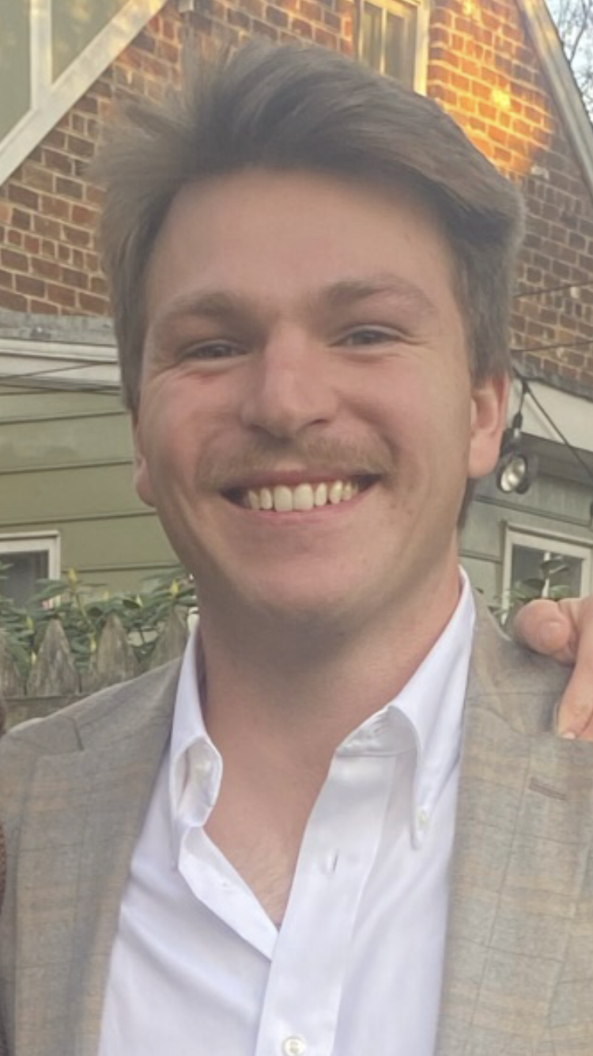 |  | EDUCATION
James Madison University
2018-2023
Majored in Communication Studies with a focus on interpersonal communication. 2019-2020 Co-philanthropy chair For Kappa Sigma

James Monroe Highschool
2014-2018
- Student council executive board President my senior year
William Dyer  Profile  William is a hardworking, team-oriented worker who enjoys seeing tasks to completion and collaborating with others to get the job done. He is physically capable of performing manual labor and maintenance tasks. Alongside his physical capabilities he also has experience in sales positions. He will have a degree In Communication Studies with a focus in Interpersonal Communication From James Madison University. William enjoys meeting new people and fostering new relationships while at work and also in his free time.  CONTACT  PHONE:  540-623-0875  LinkedIn  https://www.linkedin.com/in/williamwdyer/  EMAIL:  Williamdyer2018@gmail.com |  | WORK EXPERIENCE
Moose Head Ranch – Wrangler/Ranch hand
May 2021- August 2021
Worked daily with horses, preparing them for guests to ride on a guided tour through Grand Teton National Park. Would also help with a multitude of manual labor tasks needed at the Dude Ranch.

Summit Environmental Solutions - Construction Work crew
June – August 2019
Completed manual tasks including replacing drywall and floorboards, building decks, and leveling earth to promote drainage, protect underground piping and ready ground for planned landscaping. Interacted with homeowners in a professional and timely manner to understand job specifications and expectations prior to construction

DAG AMMO – Sales Support Staff
June 2014 – August 2019
Unloaded incoming products of ammunition (weighing 100+ lbs) off trucks, moved boxes to staging areas, sorted items, and transported to final show locations. Maintained accurate and current shipment forms, inventory documentation, costumer records and person to person sales
 |  | Activities and Community Involvment
Kappa Sigma fraternity Philanthropy chair 2019-2020
- Organized safe, socially distanced events which raised $22,000- up 730% from the prior year- for Break the Hold, an institution specializing in mental health research and awareness
Four-year member of the JMHS student council
- Class representative x 3 and Executive Board president x 1.
3-year member of SODA
- Highschool mentorship program where we went to 3rd grade classrooms once a month to work with and mentor the students.

